|  |  |
| --- | --- |
| Date | 17 November 2022 |
| Team ID | PNT2022TMID25500 |
| Project Name | Inventory Management System For Retailers |

Setting up Application Enviíonment Dockeí CLI Installation

Step 1. Download Docker from dockeí.com and install it by running the Docker Desktop Installe.exe file

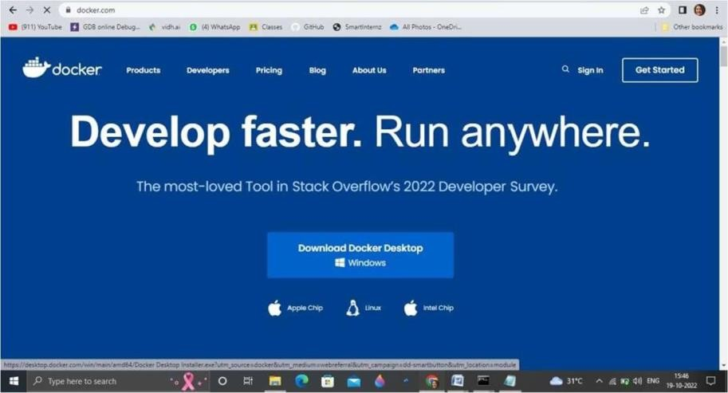

Step 2: Move to hub.docker.com register and create an account and login with the same

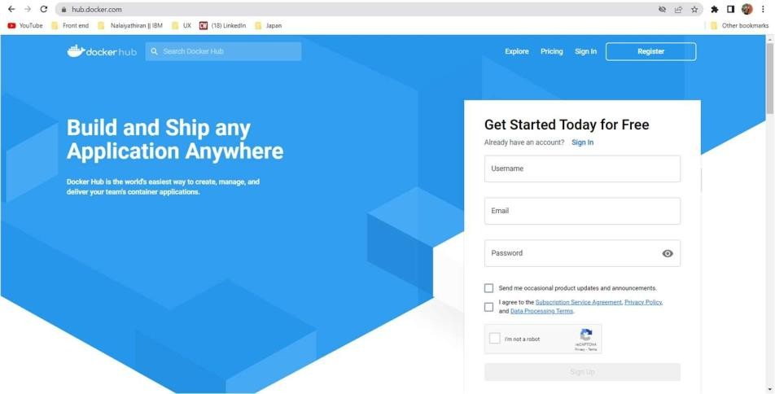

Step 3. Open Docker Desktop and start creating containers and images

